**NAME:** Chittoor Ganesh

**REGISTER NUMBER:** 713921104006

**NAAN MUDHALVAN ID:** au713921104006

**EMAIL ID:** chittoorganesh37@gmail.com

**TITLE: COVID-19 VACCINES ANALYSIS**

# Introduction

COVID-19 vaccines have been highly effective in preventing severe illness, hospitalization, and death from the virus. However, there is still much to learn about how to optimize vaccine deployment strategies to maximize their impact. This paper will conduct an in-depth analysis of COVID-19 vaccine data, including efficacy, distribution, and adverse effects, to provide insights that can aid policymakers and health organizations in making informed decisions about vaccine deployment.

**Phase3**

In this part you will begin building your project by loading and preprocessing the dataset.begin conducting the vaccine analysis by collecting and preprocessing the data.collect and preprocess the covid-19 vaccine data for analysis

**Dataset:** <https://www.kaggle.com/datasets/gpreda/covid-world-vaccination-progress>

**1. Importing Required Libraries:**

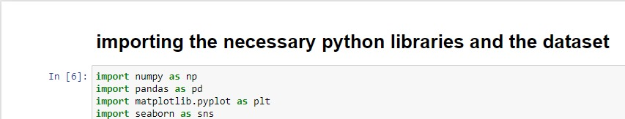

**2. Importing the dataset:**

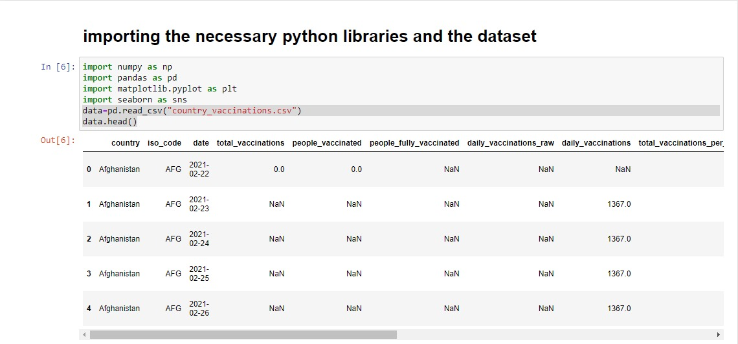

**3. Handling the missing data:**

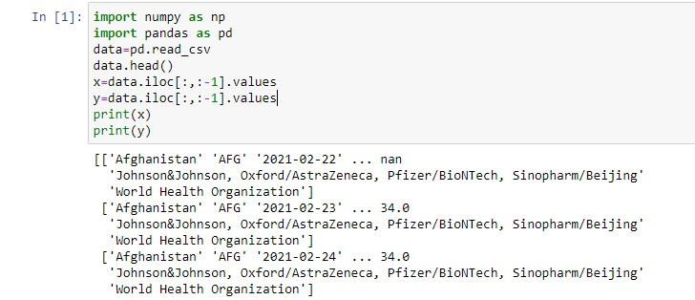

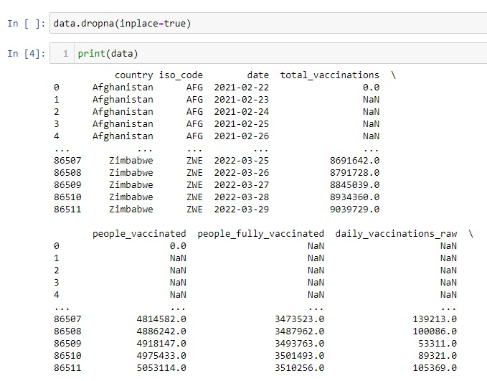

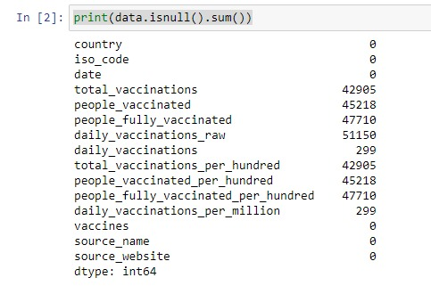

**4. Encoding the categorical data:**

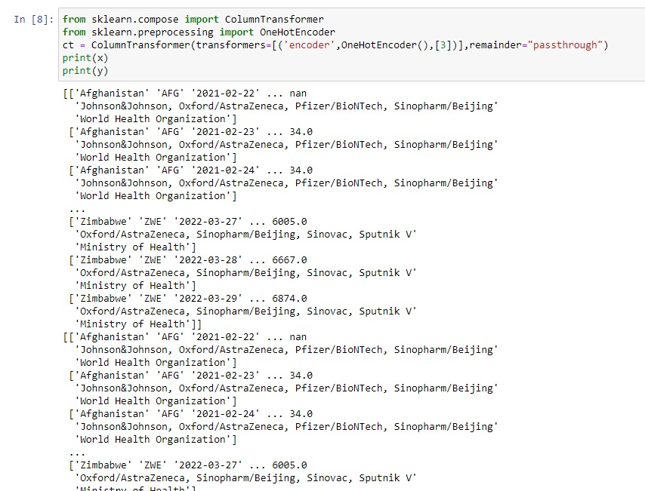

**5. Splitting the dataset into test set and training set:**

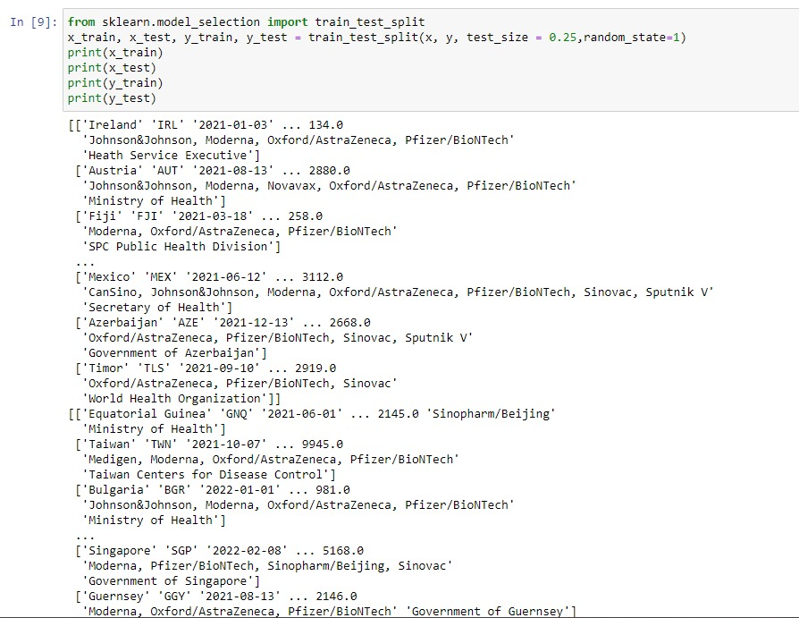

**6. Feature scaling:**

